# 1st Approach: Starting at the front of the string

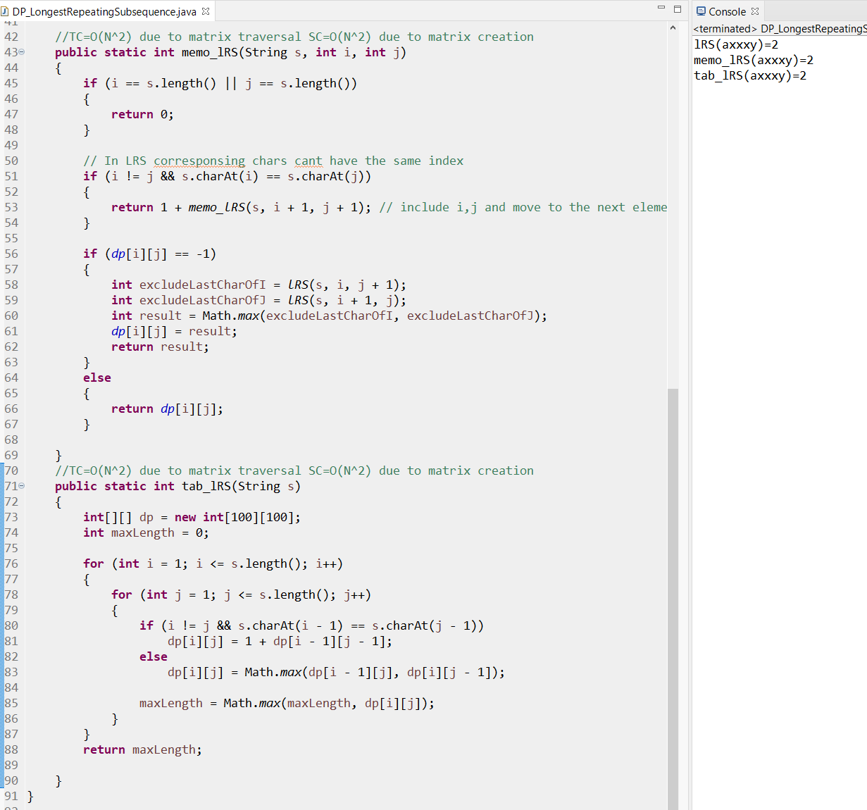

# 2nd Alternative Approach: Starting at the back of the string